Solution:

**General Linear Model: Tensile strength versus Chemical agent, Bolt Type**

**Method**

|  |  |
| --- | --- |
| Factor coding | (-1, 0, +1) |

**Factor Information**

|  |  |  |  |
| --- | --- | --- | --- |
| **Factor** | **Type** | **Levels** | **Values** |
| Chemical agent | Fixed | 4 | 1, 2, 3, 4 |
| Bolt Type | Fixed | 5 | 1, 2, 3, 4, 5 |

**Analysis of Variance**

|  |  |  |  |  |  |
| --- | --- | --- | --- | --- | --- |
| **Source** | **DF** | **Adj SS** | **Adj MS** | **F-Value** | **P-Value** |
| Chemical agent | 3 | 12.95 | 4.317 | 2.38 | 0.121 |
| Bolt Type | 4 | 157.00 | 39.250 | 21.61 | 0.000 |
| Error | 12 | 21.80 | 1.817 |  |  |
| Total | 19 | 191.75 |  |  |  |

**Model Summary**

|  |  |  |  |
| --- | --- | --- | --- |
| **S** | **R-sq** | **R-sq(adj)** | **R-sq(pred)** |
| 1.34784 | 88.63% | 82.00% | 68.42% |

**Coefficients**

|  |  |  |  |  |  |
| --- | --- | --- | --- | --- | --- |
| **Term** | **Coef** | **SE Coef** | **T-Value** | **P-Value** | **VIF** |
| Constant | 71.750 | 0.301 | 238.07 | 0.000 |  |
| Chemical agent |  |  |  |  |  |
| 1 | -1.150 | 0.522 | -2.20 | 0.048 | 1.50 |
| 2 | -0.350 | 0.522 | -0.67 | 0.515 | 1.50 |
| 3 | 0.650 | 0.522 | 1.25 | 0.237 | 1.50 |
| Bolt Type |  |  |  |  |  |
| 1 | 1.750 | 0.603 | 2.90 | 0.013 | 1.60 |
| 2 | -3.250 | 0.603 | -5.39 | 0.000 | 1.60 |
| 3 | 3.750 | 0.603 | 6.22 | 0.000 | 1.60 |
| 4 | 1.000 | 0.603 | 1.66 | 0.123 | 1.60 |

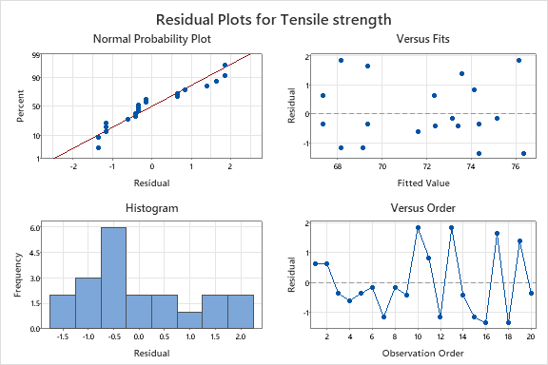

Conclusion: